Submission of Concept Paper for Financial Assistance
under Natural Sciences Linkage Programme
- Title of the Project:
Smart Irrigation for agricultural Areas of Pakistan

- Short Rationale of the Project:
Agriculture sector uses 85% of available freshwater resources worldwide, most of which are gone wasted. If the amount of water continues to be utilized by the agriculture sensor, this may poses a serious threat to the water resources. The population is growing rapidly, food and water demands are also increasing meanwhile fresh water resources are decreasing, and therefore it is required to make the efficient use of water on the first priority. There is an urgent need to create strategies based on science and technology for sustainable use of water. Smart irrigation system using state of the art computing technologies for agri area of Pakistan has been designed to counter/target the following issues and problems faced by the Agriculture sectors:

- It is very important in farming to determine, at what time, what amount of water is required by the crops. The main focus of this project is to provide controlled and timely distribution of water in the fields.

- Currently, there are no field monitoring systems available in Pakistan which could monitor a vast area/field. This project is scalable, efficient & can easily provide coverage to a large area.

- Water resources are reducing each passing year. Crops suffer badly due to lack of fresh water. In advance stage of this project we can find in advance the amount of water required in different areas and seasons. It will help framers to take appropriate decisions about cultivating new crops.

- Major Objectives:
The key objectives of this system have been identified as:

- To achieve optimum irrigation efficiency commensurate with high agriculture production and saving of fresh water.
- To provide convenience in accessing the system from anywhere at any time.
- To save the time of owner for managing large field as well as it minimize human labor.
- To make “Agriculture kit” that can be used for research, testing, development and help to learn new platform and technologies.

- Outcomes of the Project:
- The outcome of this project will be a fully automated and intelligent irrigation control system that can be controlled remotely by cell phones to preserves fresh water. This system will be powered by solar panels to reduce energy costs. This not only saves water, but also reduces costs for the field owner.

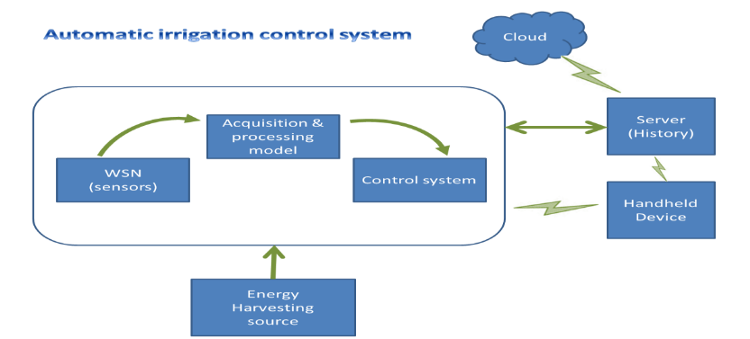
- Another outcome of this project is “agriculture kit” that will be used to support the researchers and developers in their study, training, design, and development. It is provided with application development software, multiple communication interfaces (LAN, GSM/GPRS, ZIGBee), and various sensor interfaces with plug and play capability. Its initial prototype has been completed.

- Project Domain: (Please Tick relevant)

✓ | Product Development/Improvement |  | Pilot Scale Production | ✓ | Transfer of Technology
 | Process Development/Improvement |  | Entrepreneurship | ✓ | Prototype Development
✓ | Methodology Development/Improvement | ✓ | Conservation, Protection or Restoration of species/eco-system |  | Pilot Scale Demonstration
 | Technique Development/Improvement |  | Knowledge Generation |  | Any other (please specify)
✓ | Commercialization of Existing Technology | ✓ | Commercialization of New Technology

- Estimated Budget of the Project: | Rs. 1.33 million

- Project Duration: 6 months | Proposed Date of Initiation: August 1, 2015

- Major Equipment Required:
Following heads have been estimated to constitute major budget of the project:

Item Description | Amount (in million Rs.)
Wireless Sensing network deployment | 1.1
Irrigation Equipment | 0.03
Power supply units | 0.1
Shipment cost | 0.1

- Possibility of Commercialization:
When commercializing any project its cost , advantages, portability, reliability and how much it is easy to use should be considered.The cost of proposed system is affordable and benefits are greater and long term. Many fieldowner, stakeholders will be interested because it not only save the crop production cost but also improves crop quality. They can also monitor their fields without physical presence.

The second outcome of this project which is “Agriculture kit” has many customer attracting features which are mention below:

- Custom Analog & digital sensor interfaces
- Environmental senosor interfaces with plug and play capability
- Remote programming capabilty for WSN management
- Sensors power ON/OFF controlling with GUI.
Mutiple wireless communication interfaces(Zigbee,GSM/GPRS)
- LAN connectivity
- Bettry powered with solar pannel
- Robust waterproof IP65 enclosure
- Application development software

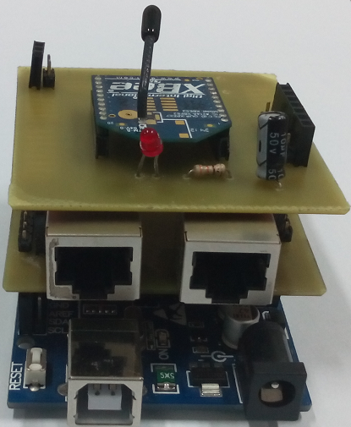
The above following features will be definitely attract customers, In pakistan local market because no such development kits are present .

The proposed system is the application of modern IoT technology that is being implemented worldwide introducing “Internet of Things” first time in Pakistan through this smart irrigation system that is likely expected to give a boost in Pakistan agriculture sector.

- End-user(s) Keen to Adopt the Project Results:

Water Conservation and Water Health

Social benefits to human resource
- Scientists/Researchers and Research Managers
- Extension/Knowledge intermediaries
- StudentsTeachers
- New Farmer Entrepreneurs
- Agri-business Entrepreneurs
- Farmers

Agriculture Fights the Effects of Global Warming

Hands on exposure/Learning

- Principal Investigator
Full name |  | Dr. Muhammad Khurram |  |  | e-mail address |  | Khurram.ned@gmail.com
Present Position |  | Associate Professor |  |  | Major field of specialization |  | Computer Engineering, IC Design
Postal Address |  | Department of Computer & Information Systems Engineering, NED University of Engineering & Technology, University Road, Karachi - 75270.
Fax | 99261255 |  | Telephone | 92-21-99261261  Ext: 2287, 2363 |  | Mobile |  | 0335-3046110

